**Linear Lab**

Given the function *f*(*x*) = _______________________________

Fill in the table:

|  |  |
| --- | --- |
| *x* | *f*(*x*) |
| -2 |  |
| 0 |  |
| 2 |  |

Write these points as ordered pairs: ( , ), ( , ), ( , )

Plot these points on the graph and join with a straight line.

Compute the slope of the line by using the formula

 where



The slope of the line shown is ________.

Find students in the class that have a line with the same slope as yours. This is your group. Compare your function and its graph with members in your group.

What do you observe? What is the same for each graph? What is different?

Write down a new function, *g*(*x*) = *mx* + 1, using the same slope that your group had for *f*(*x*).

*g*(*x*) = _________________.  Based on what you just learned, see if you can graph *g*(*x*) without plugging in any values.

Go to the website <http://www.mathsisfun.com/data/straight_line_graph.html> .

Change the value of *b* by dragging the slider bar. Does the graph do what you’d expect based on what you have seen with the lines in your group?

Now use the slider to change *m* and observe what changing *m* does to the graph of the line.

As the value of the *m* becomes larger what can you say about the line?

Drag the slider until you have a horizontal line. What is the value of the *m*? (this is the slope)

Drag the slider until if you were walking along the line from left to right you would be descending. What is the sign of *m* (the slope) when the line is descending?

Go to the website <http://www.learningwave.com/lwonline/algebra_section2/slope5.html> and have each member of your group compute the slope of a different climber and then determine the winner and enter that with the slope at the website to see if you are correct.

MORE IDEAS ABOUT SLOPE





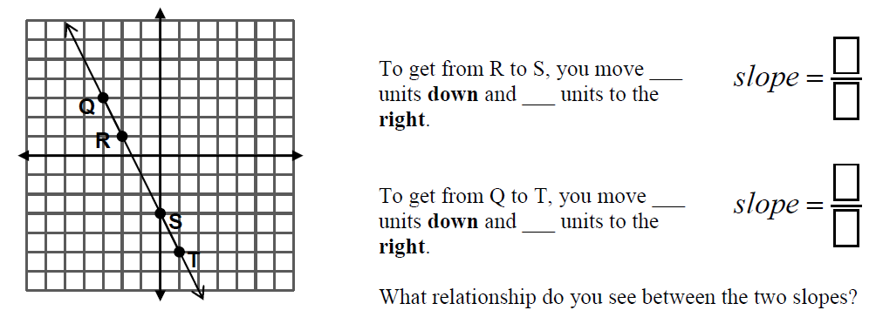

When you move **down**, since you are decreasing, you need a **negative sign** the number because you are subtracting from the *y* value where you started.

Watch the animation located at <http://rwdacad01.slcc.edu/academics/dept/math/shaider/1010TNG/graphfromslopeintform.html>

Graph the following:





Remember what the slope of a horizontal line was? So to graph a horizontal line the equation would be *y* = 0*x* + *b* or *y* = *b*.

The slope of a vertical line is undefined because any two points on a vertical line have the same value and computing  you would have 0 for the denominator.

The equation of a vertical line is *x* = *a* where *a* is the *x* value of any point on the line.

Now graph the following:





Now each member of your group should get on a computer and go to <http://funbasedlearning.com/algebra/graphing/lines/default.htm>

The object is to pick the linear equation from the choices at the bottom so that the a line drawn there will go through the most gems. Lines that go through more gems get more points. See if you can beat your groupmates!

Each member of your group should get on a computer and go to <http://funbasedlearning.com/algebra/graphing/lines/default.htm> and click “Play Game”.

The object is to pick the linear equation from the choices at the bottom so that the line drawn for that equation will go through the most gems. Lines that go through more gems get more points. See if you can beat your groupmates!