Math 1010 Radicals Name:______________________

A real-world application of radicals:

The faster a car is moving the more distance it will take to stop. Using mathematics, we can find a safe following distance for various speeds. The same concept can be used by law enforcement personnel to gather evidence after an accident occurs.

One recommendation for a safe following distance is to allow one car length for each ten miles per hour. This means, if you were driving 50 miles per hour, you should have five car lengths between your car and the car in front of you.

Suppose your car is 13.6 feet long. This is about average for a compact/mid-size car. Fill in the table below using the above recommendation of one car length for each ten miles per hour.

|  |  |
| --- | --- |
| Velocity – Miles per Hour | Recommended Distance Between Cars |
| 20 |  |
| 30 |  |
| 40 |  |
| 50 |  |
| 60 |  |
| 70 |  |

The Utah Department of Motor Vehicle’s Defensive Driving Tips (<http://www.dmv.org/ut-utah/defensive-driving.php>) recommends at least three seconds between your car and the car in front of you. There is 5280 feet in one mile.

What is the recommended distance from the Utah DMV?

Note: 

This gives you the number of feet per each second for a velocity of 20 miles per hour.

Fill in the table below for the recommended distance for three seconds between each car.

|  |  |
| --- | --- |
| Velocity – Miles per Hour | Recommended Distance Between Cars |
| 20 |  |
| 30 |  |
| 40 |  |
| 50 |  |
| 60 |  |
| 70 |  |

Your skid distance,  , is calculated using the formula  , where  is the speed or rate the car was moving when it made a skid distance that was  feet long. For each distance above, calculate the rate the car was traveling when it created the skid mark.

|  |  |
| --- | --- |
| Skid Distance L | Recommended Distance Between Cars |
| 20 |  |
| 30 |  |
| 40 |  |
| 50 |  |
| 60 |  |
| 70 |  |

Based on this information, which recommendation is safer: one car length for every 10 miles per hour or three seconds between you and the car in front of you?

If you were advising a new driver about safe following distance, what would you recommend to the new driver?

Be honest, do you drive to closely to the car in front of you?

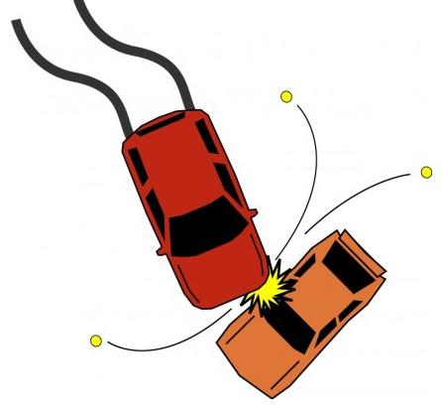

Unfortunately, the mathematics is much more complicated. The skid distance will depend of many variables. The actual formula is  where the variable  represents the coefficient of friction, the variable  represents the elevation of the road, and the variable  represents the radius of the skid mark.

Have you ever skidded in your car? Do you think the friction or elevation of the road a factor in your skid mark?

Given the function: 

1. State the domain of :
2. List five exact ordered pairs  that lie on the graph of :
3. Use your points above to sketch the graph of .
4. Write using rational exponents:



Given the function: 

1. State the domain of :
2. List five exact ordered pairs  that lie on the graph of :
3. Use your points above to sketch the graph of .
4. Write  using rational exponents.



Check your graphs with your neighbors. Do your graphs look the same? Why or why not.